# Objective

To start up your Raspberry Pi and run your first program on Raspberry Pi. The objectives of this project tutorial include:

(1) Connect RP hardware;

(2) Learn to use some basic software tools;

(3) Run RP OS;

(4) Run a program on RP.

# Components

1. Raspberry Pi Board and Power;

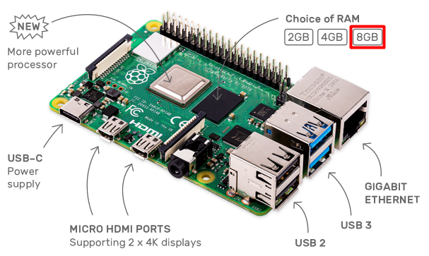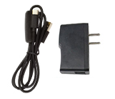

1. A 16GB SD Card and a SD Card Reader;

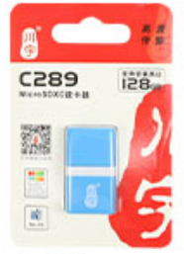

1. LCD Screen and HDMI Cable

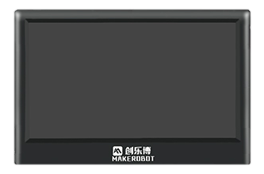 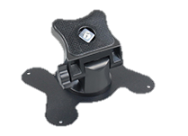

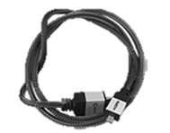

# Principle of The Experiment

## Introduction of Raspberry Pi 4B

## BCM2711 SoC of raspberry Pi 4B

BCM2711 is the Broadcom chip used in the Raspberry Pi 4 Model B. The architecture of the BCM2711 is a considerable upgrade on that used by the SoCs in earlier Pi models. It continues the quad-core CPU design of the BCM2837, but uses the more powerful ARM A72 core. It has a greatly improved GPU feature set with much faster input/output, due to the incorporation of a PCIe link that connects the USB 2 and USB 3 ports, and a natively attached Ethernet controller. It is also capable of addressing more memory than the SoCs used before.

The ARM cores are capable of running at up to 1.5 GHz, making the Pi 4 about 50% faster than the Raspberry Pi 3B+. The new VideoCore VI 3D unit now runs at up to 500 MHz. The ARM cores are 64-bit, and while the VideoCore is 32-bit, there is a new Memory Management Unit, which means it can access more memory than previous versions.

A datasheet for the BCM2711 can be found [here](https://datasheets.raspberrypi.org/bcm2711/bcm2711-peripherals.pdf).

* **Processor**: Quad-core Cortex-A72 (ARM v8) 64-bit SoC @ 1.5 GHz. See [Wikipedia page](https://en.wikipedia.org/wiki/ARM_Cortex-A72) on the A72 for more details.
* **Memory**: Accesses up to 8GB LPDDR4-2400 SDRAM (depending on model)
* **Caches**: 32 KB data + 48 KB instruction L1 cache per core. 1MB L2 cache.
* **Multimedia**: H.265 (4Kp60 decode); H.264 (1080p60 decode, 1080p30 encode); OpenGL ES, 3.0 graphics
* **I/O**: PCIe bus, onboard Ethernet port, 2 × DSI ports (only one exposed on Raspberry Pi 4B), 2 × CSI ports (only one exposed on Raspberry Pi 4B), up to 6 × I2C, up to 6 × UART (muxed with I2C), up to 6 × SPI (only five exposed on Raspberry Pi 4B), dual HDMI video output, composite video output.

# Experimental Steps

Now, let’s start the experiment step by step!

## Installing operating system images

In this part, we will install a Raspberry Pi operating system image on an SD card. We will need a Window/Mac OS computer with an SD card reader to install the image.

1. Connect an SD card reader with the SD card inside.

Make sure the SD card have enough space (>8GB).

1. Unzip the system image package “2021-03-04-raspios-buster-armhf-full.zip”

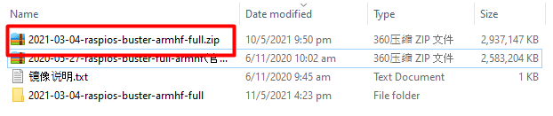

You will get the image file “2021-03-04-raspios-buster-armhf-full.img” in the corresponding folder.

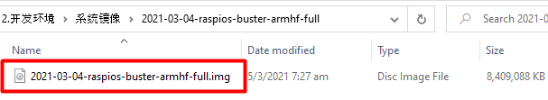

1. Download the latest version of [Raspberry Pi Imager](https://www.raspberrypi.org/downloads/) and install it.

If you are using window computer, selecting Download for Windows as below.

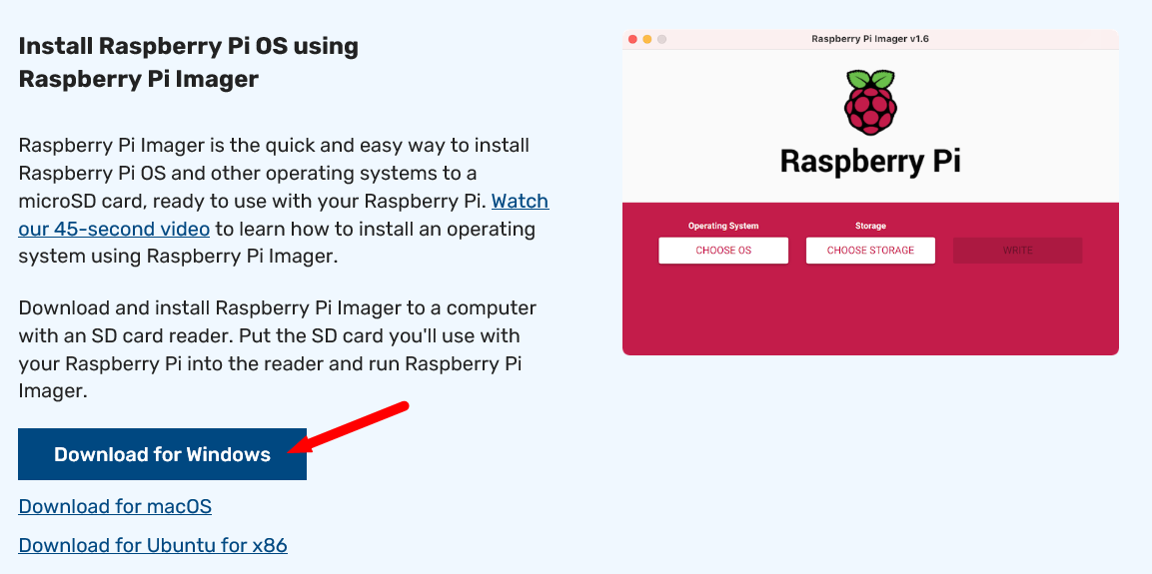

1. Open Raspberry Pi Imager, click CHOOSE OS.

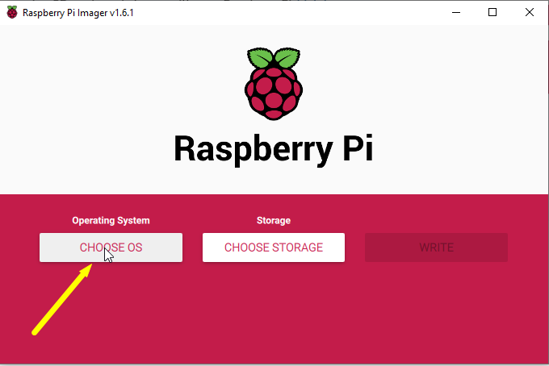

1. Click Use custom button at the bottom of the drop down box.

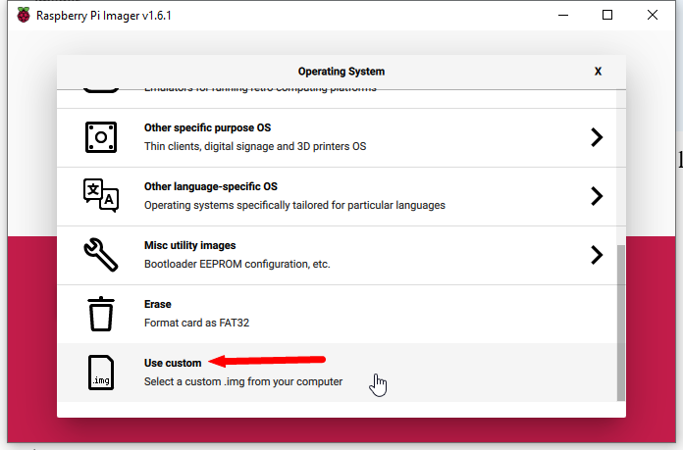

1. Select image file “2021-03-04-raspios-buster-armhf-full.img” obtained in step 2), then click Open.

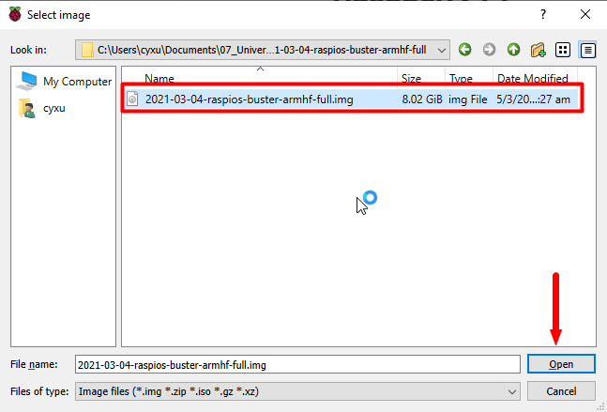

1. Click CHOOSE STORAGE and select Mass Storage Device USB Device

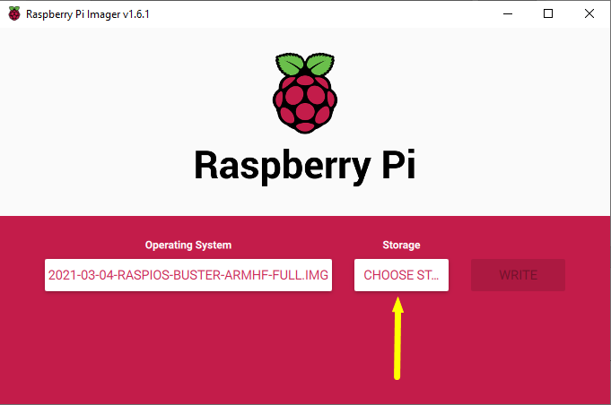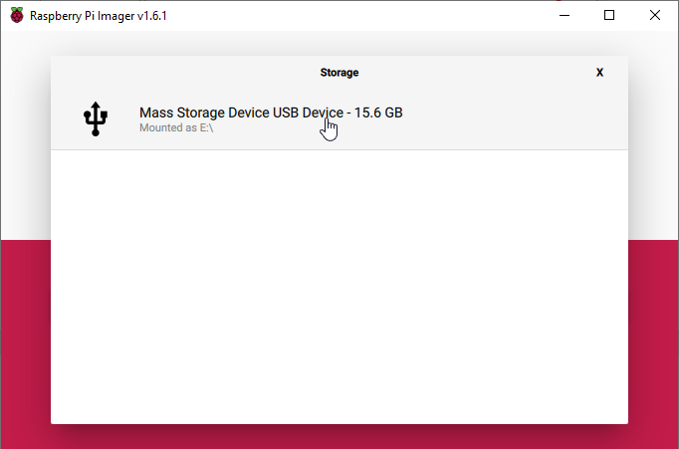

1. Click WRITE and select YES in the pop-up Warning window, then wait for writing finish!

The writing procedure would consume 10-30 minutes.

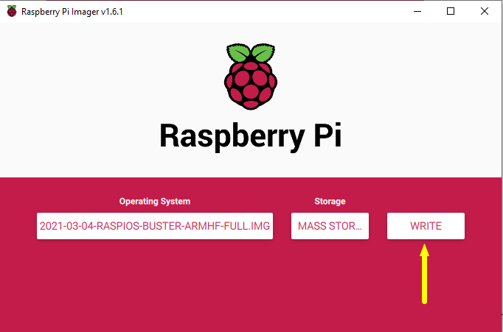

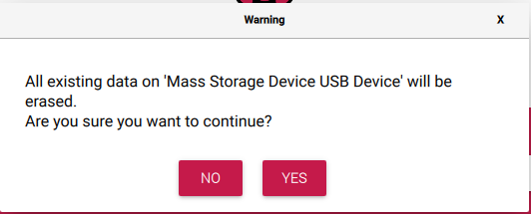

1. Click CONTINUE and close Raspberry Pi Imager when writing finish, and remove SD card reader from computer.

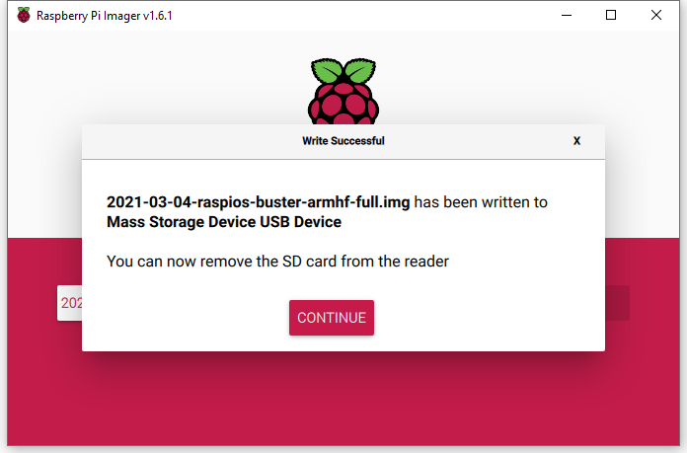

## Connect Hardware

1. Install Acrylic Case for Raspberry Pi

Warning: Never use you hand touch Pins of Raspberry Pi directly.

1. Connect Raspberry Pi Board, Power and LCD Screen

We can now insert the SD card into the Raspberry Pi and power it up.

The default user name is pi, with password raspberry

We can change the default password straight away to ensure the Raspberry Pi is secure. The steps is here.

# Code